**Full Stack Engineering Project (FSE) (22CS037)**

Project Report on

Expense Tracker

Semester-VI (Batch-2022)

(PROJECT GROUP - 10)



**Supervised By: Submitted By:**

Mr. Rahul Isha Prakash- 2210991679

Group-G-22 Ishika- 2210991687

Kanika - 2210991735

Sanskar - 2210992251

**Department of Computer Science and Engineering**

**Chitkara University Institute of Engineering & Technology**

**ABSTRACT**

The Expense Tracker Application is designed to provide users with an efficient way to manage their finances. With the increasing complexity of financial management, individuals and businesses often struggle to monitor their expenses effectively. This project offers a streamlined digital solution to bridge this gap by allowing users to record, categorize, and analyze their expenditures effortlessly.

The application supports expense logging across multiple categories such as food, travel, entertainment, and utilities. Users can set budget limits and receive alerts when nearing their spending thresholds. Additionally, interactive visualizations, including graphs and reports, provide valuable insights into spending habits. Features such as real-time data updates, secure authentication, and the ability to export financial reports in PDF or Excel format enhance the application's usability.

Developed using modern technologies, the application employs a robust backend for secure data handling and a responsive frontend for an intuitive user experience. Best practices in software development were implemented to ensure scalability, security, and maintainability. Extensive testing was conducted to deliver a reliable and high-performance product.

By offering a user-friendly interface and advanced financial tools, the Expense Tracker Application serves as a practical financial assistant for individuals, families, and small businesses. Future enhancements, such as AI-driven financial insights and automated expense categorization, will further elevate its functionality.

**TABLE OF CONTENTS**

|  |  |  |
| --- | --- | --- |
| SR NO. | TITLE | PAGE NO. |
| 1. | Introduction | 4 |
| 2. | Objectives | 5 |
| 3. | Features and Functionalities | 6 |
| 4. | Testing and Evaluation | 7 |
| 5. | Challenges and Solutions | 8 |
| 6. | Snapshots of the project | 9-14 |
| 7. | Future Scope | 15 |
| 8. | Conclusion | 16 |
| 9. | References | 17 |

1. **INTRODUCTION :**

Managing finances effectively is crucial in today’s fast-paced world, yet many individuals and businesses struggle with tracking expenses and adhering to budgets. Traditional methods such as spreadsheets and manual logging are prone to errors and inefficiencies.

#### ****Problem Statement****

Existing financial tracking methods are cumbersome and lack intelligent insights. This project aims to provide a digital solution that simplifies financial management while ensuring accuracy and accessibility.

#### ****Purpose of the Project****

The Expense Tracker Application offers a convenient, digital approach to tracking expenses, enhancing budgeting, and increasing financial awareness.

#### **Scope of the Application**

Designed for individuals, families, and small businesses, the application provides structured tools for monitoring, categorizing, and analyzing expenditures.

#### **Features Overview**

Categorized expense tracking (food, travel, utilities, etc.).

Secure user authentication for data privacy.

By automating expense tracking, the application reduces manual efforts and empowers users to make informed financial decisions.

1. **OBJECTIVE:**

The primary objective of the Expense Tracker Application is to provide an efficient and user-friendly platform for managing financial activities. The application aims to simplify the process of logging expenses by categorizing them into predefined groups such as food, travel, and utilities, ensuring a structured approach to financial tracking. Additionally, it offers budget management tools, enabling users to set spending limits for specific periods and receive alerts when they approach or exceed these limits. To promote financial awareness, the application generates detailed reports and visualizations, such as pie charts and bar graphs, to help users analyze their spending habits and identify areas for improvement.

A key focus of the project is data security and privacy, achieved through robust authentication methods and encryption to protect sensitive financial information. Designed for accessibility, the application provides an intuitive interface suitable for users of all technical backgrounds, accessible across multiple platforms, including desktops and mobile devices. Furthermore, the application is built to be scalable, allowing for future enhancements such as AI-driven insights, automatic expense categorization, and integration with banking services for real-time tracking. By addressing these objectives, the Expense Tracker Application fosters better financial literacy, promotes budgeting habits, and empowers users to achieve their financial goals.

## **3.FEATURES AND FUCTIONALITIES:**

The Expense Tracker Application provides several features that enhance financial management efficiency:

* **User Authentication & Security:** The application uses multi-factor authentication (MFA) and data encryption to ensure secure access. Users must verify their identity before accessing financial data, preventing unauthorized access and data breaches.
* **Expense Categorization:** Users can log their expenses under predefined categories such as food, travel, utilities, and entertainment. Additionally, the system allows custom category creation, making it adaptable to different financial tracking needs.
* **Budget Alerts:** Users can set monthly, weekly, or category-specific budgets. The application provides real-time alerts when spending approaches or exceeds predefined limits, helping users maintain better financial discipline.
* **Visual Reports & Analytics:** The application generates detailed reports with various visualization tools:
* **Pie Charts:** Represent expense distribution across different categories.
* **Bar Graphs:** Display spending trends over time.
* **Line Graphs:** Show cumulative expense growth for better financial planning.
* **Summary Reports:** Provide an overview of financial health, helping users identify overspending areas.
* **Multi-Platform Access:** The Expense Tracker is available on desktops, smartphones, and tablets. Real-time synchronization ensures that users can access and update their financial data across multiple devices seamlessly.
* **Exporting Reports:** Users can export expense reports in multiple formats, including PDF, Excel, and CSV. This feature is particularly useful for business users and individuals who need to share financial summaries with accountants or track long-term financial trends.

### **4.TESTING AND EVALUATION:**

### Extensive testing was conducted to ensure the application functions smoothly, remains secure, and meets user expectations. The key testing phases included:

* **Unit Testing:** Each individual module, including expense logging, budget tracking, and report generation, was tested separately to confirm that all components function as intended.
* **Integration Testing:** This phase ensured that different modules, such as the frontend, backend, and database, work together seamlessly. It tested whether user inputs were correctly stored, retrieved, and displayed across all modules.
* **System Testing:** The entire application was evaluated as a whole to check for performance issues, bugs, and feature functionality. This included testing for smooth navigation between screens and verifying the accuracy of reports generated.
* **Usability Testing:** A group of beta users was asked to navigate through the application to assess its ease of use and user-friendliness. Feedback collected from users was used to refine the interface, ensuring a better user experience.
* **Performance Testing:** This involved checking the application's response time, especially when handling large volumes of expense data. It tested scenarios where thousands of transactions were logged to ensure that the system does not slow down under heavy load.
* **Security Testing:** Ensuring data privacy and protection was a priority. Security tests were conducted to prevent vulnerabilities such as SQL injection, unauthorized access, and data breaches.

## **5.CHALLENGES AND SOLUTIONS:**

During the development of the Expense Tracker Application, several challenges were encountered, which required strategic solutions to ensure optimal functionality and user experience.

* **Real-Time Data Synchronization:** One of the primary challenges was ensuring that expense data updates instantly across multiple devices. Any delay or inconsistency in data synchronization could lead to inaccurate financial records.
* **Solution:** WebSocket technology was implemented to facilitate instant updates and ensure that all devices reflect the most current financial data.
* **Performance Optimization with Large Data Sets:** As users log multiple transactions over time, the database's performance can degrade, leading to slower response times, particularly when generating reports.
* **Solution:** Database indexing and caching mechanisms were introduced to improve query efficiency. Additionally, optimized algorithms were used for generating financial reports, ensuring smooth operation even with large datasets.
* **Ensuring Data Security and Privacy:** Handling sensitive financial information requires robust security measures to prevent unauthorized access and data breaches.
* **Solution:** Strong authentication mechanisms such as multi-factor authentication (MFA) were implemented. Furthermore, end-to-end encryption was used to protect stored financial data, reducing risks associated with cyber threats.
* **User-Friendly Interface Design:** Some users, particularly those not well-versed in digital finance tools, found the initial interface complex and challenging to navigate.
* **Solution:** A more intuitive UI was designed, featuring simplified navigation, clear icons, and step-by-step guides for first-time users. Interactive dashboards and visual reports were also incorporated to enhance usability.

VE CHALLENGES AND SOLUTIONS IN DETAIL CHALLENGES AND SOLUTIONS IN DETAIL

**6. SNAPSHOTS OF THE PROJECT:**

Login page:

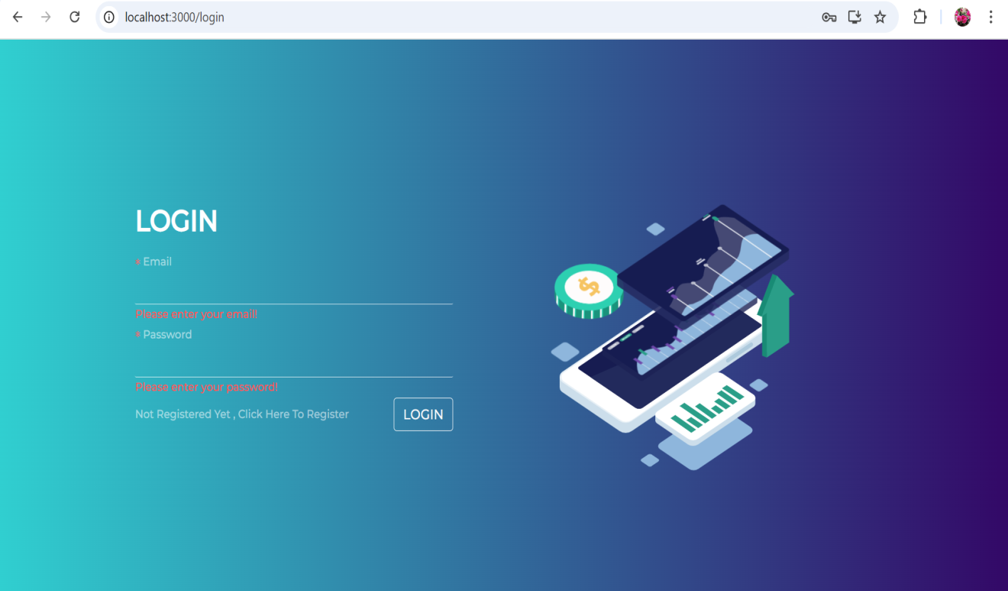

Transaction page:

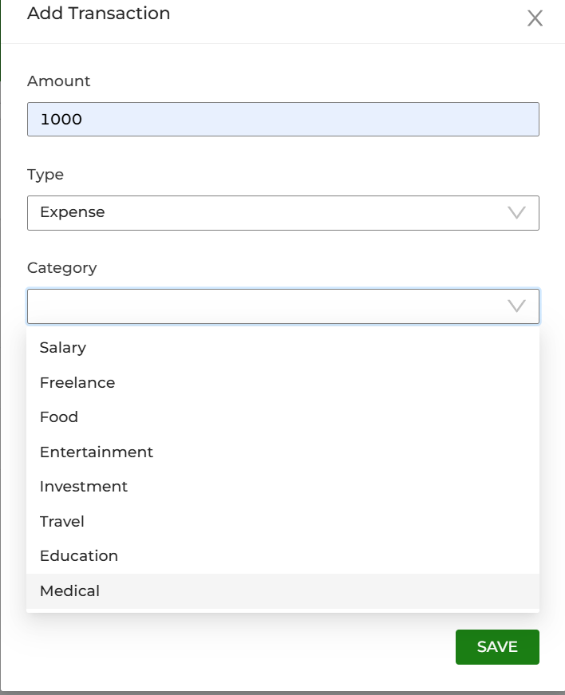

Expense Tracker page:

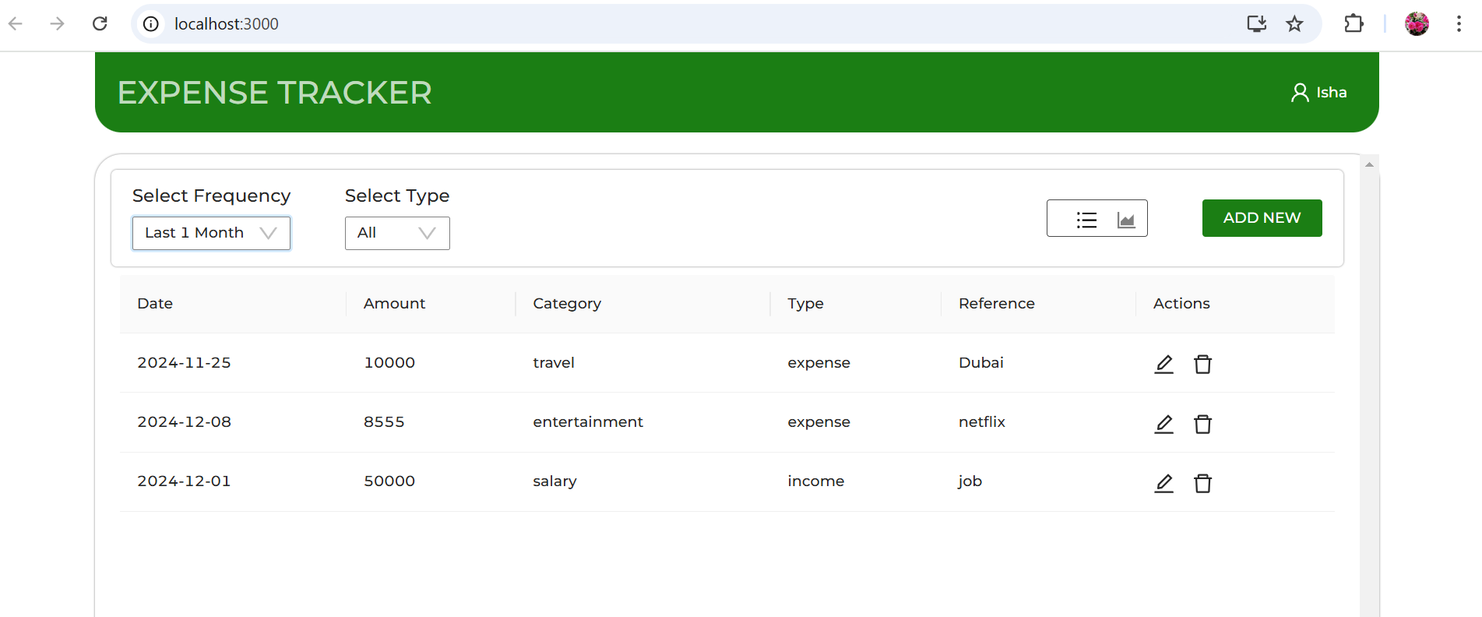

Total transactions Graph:

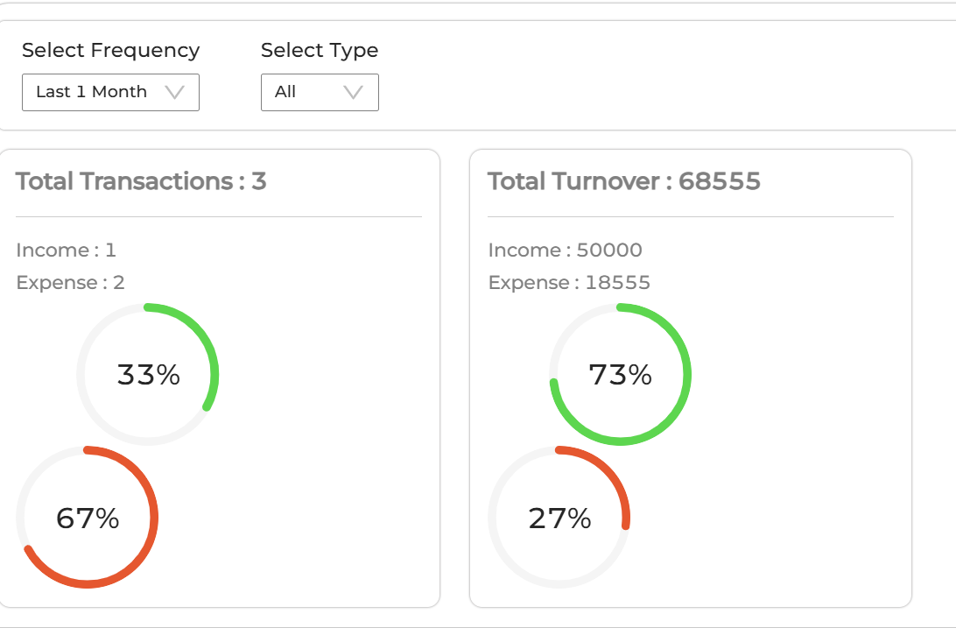

Code Snippets:

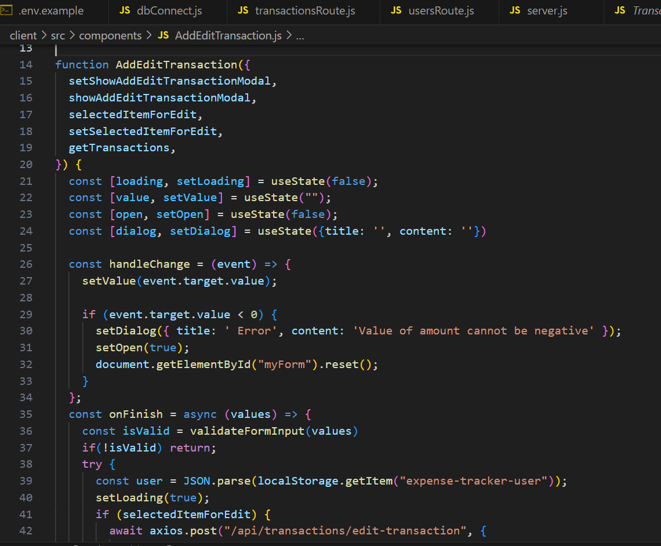

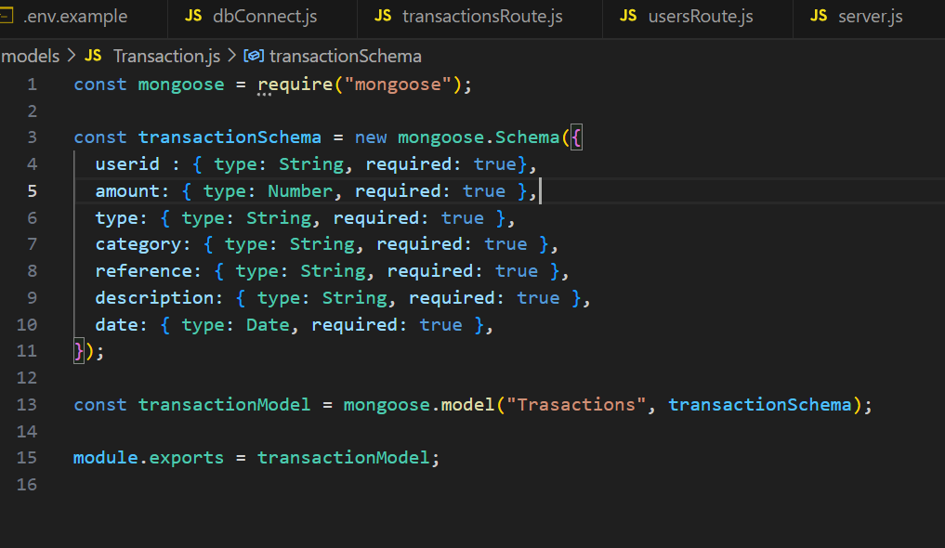

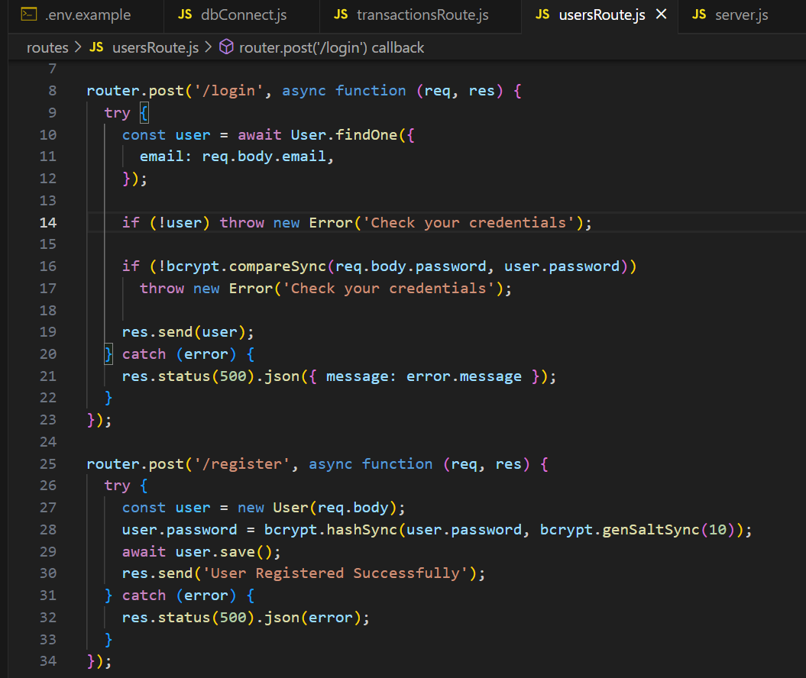

1. **FUTURE SCOPE:**

The Expense Tracker Application has vast potential for future enhancements and expansions to better serve users' financial needs. One key area of improvement is **banking integration**, where the application could be linked directly with users’ bank accounts, enabling automatic transaction logging and reducing manual entry efforts. This feature would provide real-time synchronization between financial transactions and the application, ensuring accurate and up-to-date financial records.

Another crucial enhancement would be **AI-based financial insights**, which would use machine learning algorithms to analyze spending patterns and provide personalized budgeting recommendations. This feature would help users make informed financial decisions, optimize their expenses, and identify opportunities for savings. Additionally, predictive analytics could be integrated to forecast upcoming expenses based on historical data, helping users prepare for financial obligations in advance.

Expanding the application to support **multi-currency and multilingual options** would make it more accessible to a global audience. Users from different regions could manage their finances in their preferred currency and language, allowing for broader adoption and ease of use. Furthermore, implementing **investment and savings tracking** would transform the Expense Tracker from a simple expense management tool into a comprehensive financial planning solution. Users could monitor their investments, track savings goals, and receive insights on optimizing their financial growth.

**8.CONCLUSION:**

The Expense Tracker Application is an innovative tool that simplifies financial management by offering efficient expense tracking, budgeting, and detailed analytics. By addressing key financial challenges such as real-time data synchronization, security concerns, and performance optimization, the application provides users with a seamless and reliable experience. The incorporation of budget alerts, visual spending insights, and secure authentication mechanisms ensures that users can efficiently manage their finances while maintaining data security and privacy.

Through extensive testing and problem-solving, the application has evolved into a robust financial management platform. Its user-friendly interface makes it accessible to individuals, families, and small businesses, offering a practical solution for expense tracking and budgeting. The ability to generate detailed reports and visualize spending patterns empowers users to take control of their financial decisions.

Looking ahead, the application's scalability ensures that future enhancements, such as AI-driven financial insights, banking integration, and investment tracking, will further strengthen its capabilities. As financial management continues to evolve, the Expense Tracker Application will continue to adapt, providing users with smarter, more efficient ways to track their expenses and optimize their financial health. Ultimately, this application is not just a tool but a valuable financial companion that enables users to achieve their financial goals with confidence.

**9.REFERENCES:**

* **"Introduction to Blockchain in Finance."** (2022). Blockchain Research Institute.
* **“Expense Tracker Application Overview.”** (2024). Official Documentation, Expense Tracker App Development Team.